|  |  |  |  |  |  |  |  |  |  |  |
| --- | --- | --- | --- | --- | --- | --- | --- | --- | --- | --- |
| **ARYAMAN MISHRA 19BCE1027 LAB 1** | | | |  |  |  |  |  |  |  |
| Column , Bar, Line, Scatter Chart, Waterfall chart, Area Chart, waterfall chart | | | |  |  |  |  |  |  |  |
| Charts have been made in Sheet 2,3,4,5,6,7 | | |  |  |  |  |  | Numbers Table Name | Excel Worksheet Name | |
|  |  | Activity | Start time | End Time | Happiness  Level |  |  |  |  |  |
|  |  | wake up | 06:00 | 06:02 | 3 |  |  |  |  |  |
|  |  | have breakfast | 06:05 | 06:15 | 8 |  |  | Column Chart | Sheet2 |  |
|  |  | brush your teeth | 06:20 | 06:23 | 2 |  |  |  |  |  |
|  |  | take a shower | 06:25 | 06:35 | 5 |  |  | Line Chart | Sheet3 |  |
|  |  | take a bath | 06:36 | 06:40 | 7 |  |  |  |  |  |
|  |  | get dressed | 06:40 | 07:00 | 4 |  |  | Bar Chart | Sheet4 |  |
|  |  | go to school | 07:10 | 07:30 | 1 |  |  |  |  |  |
|  |  | study English | 08:00 | 08:40 | 9 |  |  | Pie Chart | Sheet5 |  |
|  |  | have lunch | 10:10 | 10:30 | 9 |  |  |  |  |  |
|  |  | wash the dishes | 11:00 | 11:10 | 1 |  |  | Scatter Chart | Sheet6 |  |
|  |  | read a book | 11:10 | 11:50 | 8 |  |  |  |  |  |
|  |  | do your homework | 12:00 | 13:00 | 2 |  |  | Waterfall Chart | Sheet7 |  |
|  |  | cook dinner | 21:00 | 21:30 | 2 |  |  |  |  |  |
|  |  | go to bed | 23:00 | 05:59 | 9 |  |  | Area Chart | Sheet8 |  |
|  |  | practice the guitar | 13:00 | 13:30 | 9 |  |  |  |  |  |
|  |  | play with friends | 16:15 | 18:00 | 9 |  |  |  |  |  |
|  |  | exercise | 18:05 | 19:00 | 6 |  |  |  |  |  |
|  |  | brush your hair | 14:00 | 14:02 | 1 |  |  |  |  |  |
|  |  | go shopping | 14:05 | 14:45 | 9 |  |  |  |  |  |
|  |  | go for a walk | 20:00 | 20:05 | 9 |  |  |  |  |  |
|  |  | take out the trash | 20:06 | 20:10 | 1 |  |  |  |  |  |
|  |  | clean the house | 20:15 | 20:30 | 5 |  |  |  |  |  |
|  |  | read the newspaper | 23:00 | 23:10 | 7 |  |  |  |  |  |
|  |  | surf the internet | 23:10 | 23:30 | 8 |  |  |  |  |  |
|  |  | water the plants | 14:45 | 14:50 | 8 |  |  |  |  |  |
|  |  | watch TV | 14:50 | 15:20 | 9 |  |  |  |  |  |
|  |  | relax | 15:20 | 15:30 | 9 |  |  |  |  |  |
|  |  | listen to music | 15:30 | 15:40 | 9 |  |  |  |  |  |
|  |  | do the laundry | 15:40 | 15:45 | 2 |  |  |  |  |  |
|  |  | iron the clothes | 15:45 | 15:50 | 2 |  |  |  |  |  |
|  |  | feed the dog | 15:50 | 15:55 | 7 |  |  |  |  |  |
|  |  | walk the dog | 15:55 | 16:00 | 8 |  |  |  |  |  |
|  |  | take a taxi | 16:00 | 16:15 | 9 |  |  |  |  |  |

|  |  |  |  |
| --- | --- | --- | --- |
| Numbers Sheet Name | Numbers Table Name | Excel Worksheet Name | |
|  |  |  |  |
| Sheet2 |  |  |  |
|  | Column Chart | Sheet2 |  |
| Sheet3 |  |  |  |
|  | Line Chart | Sheet3 |  |
| Sheet4 |  |  |  |
|  | Bar Chart | Sheet4 |  |
| Sheet5 |  |  |  |
|  | Pie Chart | Sheet5 |  |
| Sheet6 |  |  |  |
|  | Scatter Chart | Sheet6 |  |
| Sheet7 |  |  |  |
|  | Waterfall Chart | Sheet7 |  |
| Sheet8 |  |  |  |
|  | Area Chart | Sheet8 |  |

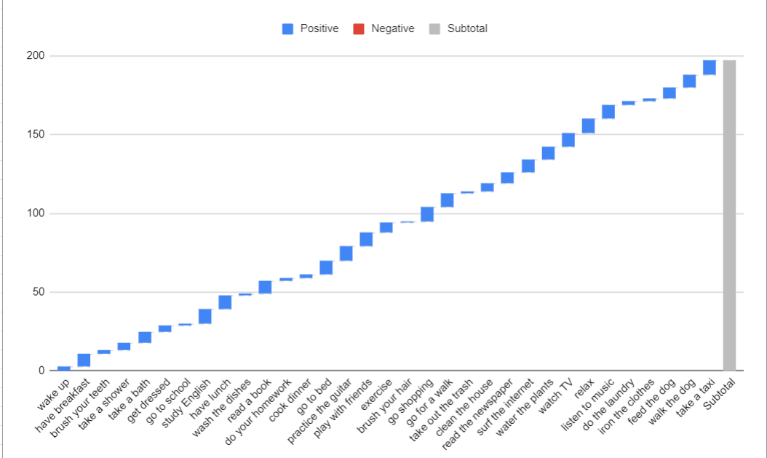

**ARYAMAN MISHRA 19BCE1027**

**LAB 2**

**CODE**

mat= c(18,18,29,20,20,29,18)

print(mat)

age=10

print(age)

t=table(mat)

print(t)

mat= c(18,18,19,20,20,19,18)

print(length(mat))

print(table(mat))

df=read.csv("C:\\Users\\aryam\\Desktop\\Fall Sem 2021\\Data Visualization Lab\\LAB 2 10-8-21\\HRDataset_v14.csv")

print(df)

print(ncol(df))

print(length(df))

print(nrow(df))

names(df)

unique(df$MaritalDesc)

barplot(df$Salary)

barplot(df$Salary, main="Salary of Employees", xlab="Employees", ylab="Salary in Rs.")

plot(df$EmpID,df$Salary) # Scatter plot

plot(df$EmpID,df$Salary, type='l')

barplot(table(mat),main="Age Count of 10 Students", xlab="Age",ylab="Count",border="red",col="blue",density=30)

**CONSOLE:**

mat= c(18,18,29,20,20,29,18)

> print(mat)

[1] 18 18 29 20 20 29 18

> age=10

> print(age)

[1] 10

> t=table(mat)

> print(t)

mat

18 20 29

3 2 2

> mat= c(18,18,19,20,20,19,18,20,19,18)

> print(length(mat))

[1] 10

> print(table(mat))

mat

18 19 20

4 3 3

> df=read.csv("C:\\Users\\aryam\\Desktop\\Fall Sem 2021\\Data Visualization Lab\\LAB 2 10-8-21\\HRDataset_v14.csv")

> print(df)

print(ncol(df))

[1] 36

> print(length(df))

[1] 36

> print(nrow(df))

[1] 311

> names(df)

[1] "ï..Employee_Name" "EmpID" "MarriedID" "MaritalStatusID"

[5] "GenderID" "EmpStatusID" "DeptID" "PerfScoreID"

[9] "FromDiversityJobFairID" "Salary" "Termd" "PositionID"

[13] "Position" "State" "Zip" "DOB"

[17] "Sex" "MaritalDesc" "CitizenDesc" "HispanicLatino"

[21] "RaceDesc" "DateofHire" "DateofTermination" "TermReason"

[25] "EmploymentStatus" "Department" "ManagerName" "ManagerID"

[29] "RecruitmentSource" "PerformanceScore" "EngagementSurvey" "EmpSatisfaction"

[33] "SpecialProjectsCount" "LastPerformanceReview_Date" "DaysLateLast30" "Absences"

> unique(df$MaritalDesc)

[1] "Single" "Married" "Divorced" "Widowed" "Separated"

> barplot(df$Salary)

> barplot(df$Salary, main="Salary of Employees", xlab="Employees", ylab="Salary in Rs.")

> plot(df$EmpID,df$Salary) # Scatter plot

> plot(df$EmpID,df$Salary, type='l')

> barplot(table(mat),main="Age Count of 10 Students", xlab="Age",ylab="Count",border="red",col="blue",density=30)

>

**PLOT:**

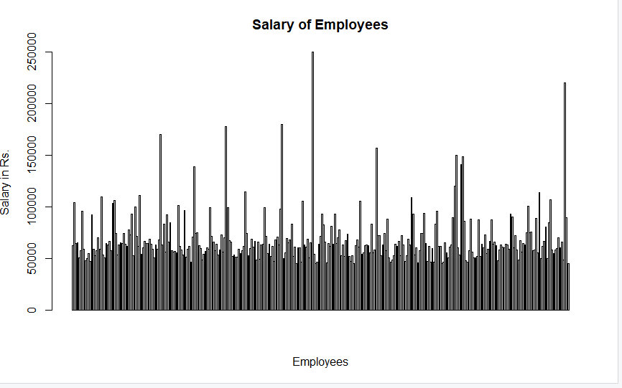 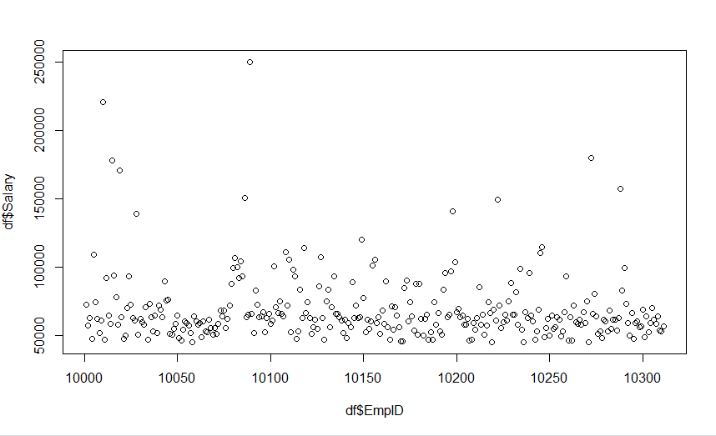 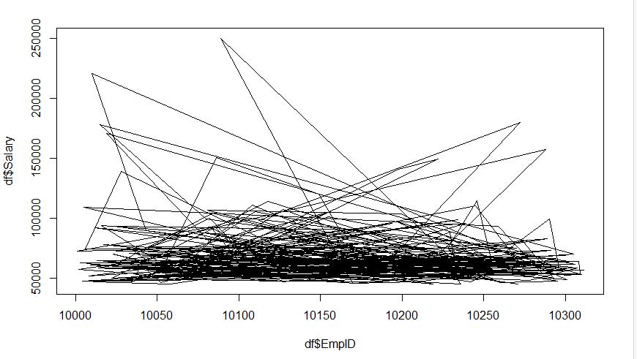

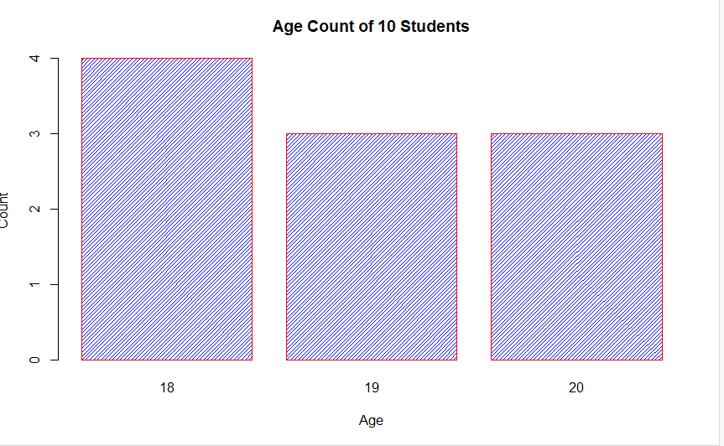

df=read.csv("C:\\Users\\aryam\\Desktop\\Fall Sem 2021\\Data Visualization Lab\\LAB 2 10-8-21\\HRDataset_v14.csv")

df2=unique(df$MaritalDesc)

df2

df3=df$MaritalDesc

df3

table(df3)

barplot(table(df3),

main="Number of People with Marital Status",

xlab="Marital Status",

ylab="Number of Employees",

border="red",

col="blue",

density=10

)

**CONSOLE:**

> df=read.csv("C:\\Users\\aryam\\Desktop\\Fall Sem 2021\\Data Visualization Lab\\LAB 2 10-8-21\\HRDataset_v14.csv")

> df2=unique(df$MaritalDesc)

> df2

[1] "Single" "Married" "Divorced" "Widowed" "Separated"

> df3=df$MaritalDesc

> df3

[1] "Single" "Married" "Married" "Married" "Divorced" "Single" "Single" "Widowed" "Single"

[10] "Divorced" "Married" "Married" "Divorced" "Single" "Divorced" "Single" "Married" "Single"

[19] "Single" "Single" "Single" "Divorced" "Married" "Single" "Single" "Single" "Married"

[28] "Single" "Married" "Married" "Single" "Separated" "Married" "Single" "Married" "Single"

[37] "Single" "Single" "Single" "Single" "Single" "Single" "Married" "Single" "Single"

[289] "Married" "Divorced" "Divorced" "Single" "Married" "Married" "Single" "Single" "Married"

[298] "Single" "Single" "Widowed" "Single" "Married" "Divorced" "Single" "Single" "Single"

[307] "Single" "Single" "Single" "Single" "Widowed"

> table(df3)

df3

Divorced Married Separated Single Widowed

30 124 12 137 8

> barplot(table(df3),

+ main="Number of People with Marital Status",

+ xlab="Marital Status",

+ ylab="Number of Employees",

+ border="red",

+ col="blue",

+ density=10

+ )

>

**Plot:**

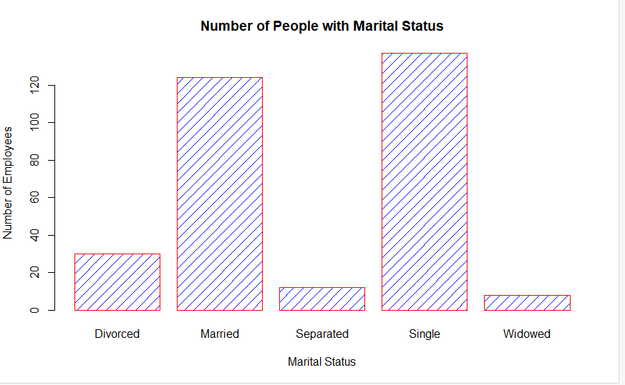

**CODE:**

df=read.csv("C:\\Users\\aryam\\Desktop\\Fall Sem 2021\\Data Visualization Lab\\LAB 2 10-8-21\\HRDataset_v14.csv")

plot(df$EmpID,df$Salary, type='l')

barplot(df$Salary, main="Salary of Employees", xlab="Employees", ylab="Salary in Rs.")

plot(x = df$EmpID,y = df$Salary,xlab = "Employee ID",ylab = "Salary",main = "Employee ID and Salary Scatter")

CONSOLE:

df=read.csv("C:\\Users\\aryam\\Desktop\\Fall Sem 2021\\Data Visualization Lab\\LAB 2 10-8-21\\HRDataset_v14.csv")

plot(df$EmpID,df$Salary, type='l')

barplot(df$Salary, main="Salary of Employees", xlab="Employees", ylab="Salary in Rs.")

plot(x = df$EmpID,y = df$Salary,xlab = "Employee ID",ylab = "Salary",main = "Employee ID and Salary Scatter")

**PLOT:**







**CODE:**

df=read.csv("C:\\Users\\aryam\\Desktop\\Fall Sem 2021\\Data Visualization Lab\\LAB 2 10-8-21\\race_wins_1950-2020.csv")

df2=unique(df$Team)

df2

df3=df$Team

table(df3)

barplot(table(df3),

main="Number of Race Wins(x:Teams,y:Race Wins)",

ylab="Race Wins",

ylim=c(1,350),

border="red",

col="blue",

density=10,las=3

)

plot(table(df$Venue), type='l',main="Races held at Venue",xlab="Venues",ylab="Races held",las=3)

plot(x = df$ID,y = df$Laps,xlab = "Race ID",ylim=c(1,200),ylab = "Laps",main = "Laps at every Race",las=1)

**console:**

df=read.csv("C:\\Users\\aryam\\Desktop\\Fall Sem 2021\\Data Visualization Lab\\LAB 2 10-8-21\\HRDataset_v14.csv")

> plot(df$EmpID,df$Salary, type='l')

> barplot(df$Salary, main="Salary of Employees", xlab="Employees", ylab="Salary in Rs.")

> plot(x = df$EmpID,y = df$Salary,xlab = "Employee ID",ylab = "Salary",main = "Employee ID and Salary Scatter")

> df=read.csv("C:\\Users\\aryam\\Desktop\\Fall Sem 2021\\Data Visualization Lab\\LAB 2 10-8-21\\race_wins_1950-2020.csv")

> df2=unique(df$Team)

> df2

[1] "Alfa Romeo" "Kurtis Kraft Offenhauser" "Ferrari" "Kuzma Offenhauser"

[5] "Maserati" "Mercedes-Benz" "Watson Offenhauser" "Epperly Offenhauser"

[9] "Vanwall" "Cooper Climax" "BRM" "Lotus Climax"

[13] "Porsche" "Brabham Climax" "Honda" "Brabham Repco"

[17] "Lotus BRM" "Cooper Maserati" "Lotus Ford" "Eagle Weslake"

[21] "McLaren Ford" "Matra Ford" "Brabham Ford" "March Ford"

[25] "Tyrrell Ford" "Hesketh Ford" "Penske Ford" "Wolf Ford"

[29] "Ligier Matra" "Shadow Ford" "Brabham Alfa Romeo" "Ligier Ford"

[33] "Renault" "Williams Ford" "Brabham BMW" "McLaren TAG"

[37] "Williams Honda" "Lotus Renault" "Benetton BMW" "Lotus Honda"

[41] "McLaren Honda" "Williams Renault" "Benetton Ford" "Benetton Renault"

[45] "Ligier Mugen Honda" "McLaren Mercedes" "Jordan Mugen Honda" "Stewart Ford"

[49] "Williams BMW" "Jordan Ford" "Sauber BMW" "STR Ferrari"

[53] "Brawn Mercedes" "RBR Renault" "Red Bull Racing Renault" "Mercedes"

[57] "Red Bull Racing TAG Heuer" "Red Bull Racing Honda" "AlphaTauri Honda" "Racing Point BWT Mercedes"

> df3=df$Team

> table(df3)

df3

Alfa Romeo AlphaTauri Honda Benetton BMW Benetton Ford

11 1 1 14

Benetton Renault Brabham Alfa Romeo Brabham BMW Brabham Climax

12 2 8 2

Brabham Ford Brabham Repco Brawn Mercedes BRM

15 8 8 17

Cooper Climax Cooper Maserati Eagle Weslake Epperly Offenhauser

14 2 1 2

Ferrari Hesketh Ford Honda Jordan Ford

239 1 3 1

Jordan Mugen Honda Kurtis Kraft Offenhauser Kuzma Offenhauser Ligier Ford

3 5 1 5

Ligier Matra Ligier Mugen Honda Lotus BRM Lotus Climax

3 1 1 24

Lotus Ford Lotus Honda Lotus Renault March Ford

47 2 7 3

Maserati Matra Ford McLaren Ford McLaren Honda

9 9 35 44

McLaren Mercedes McLaren TAG Mercedes Mercedes-Benz

78 25 106 9

Penske Ford Porsche Racing Point BWT Mercedes RBR Renault

1 1 1 15

Red Bull Racing Honda Red Bull Racing Renault Red Bull Racing TAG Heuer Renault

5 35 9 35

Sauber BMW Shadow Ford Stewart Ford STR Ferrari

1 1 1 1

Tyrrell Ford Vanwall Watson Offenhauser Williams BMW

23 10 3 10

Williams Ford Williams Honda Williams Renault Wolf Ford

17 23 64 3

> barplot(table(df3),

+ main="Number of Race Wins(x:Teams,y:Race Wins)",

+ ylab="Race Wins",

+ ylim=c(1,350),

+ border="red",

+ col="blue",

+ density=10,las=3

+ )

> plot(table(df$Venue), type='l',main="Races held at Venue",xlab="Venues",ylab="Races held",las=3)

> plot(x = df$ID,y = df$Laps,xlab = "Race ID",ylim=c(1,200),ylab = "Laps",main = "Laps at every Race",las=1)

PLOT:

